CIS 3400

Jake Li

Project Report

**Topic Description** ([Supermarket Sales | Kaggle](https://www.kaggle.com/aungpyaeap/supermarket-sales))

My dataset is supermarket sales. I found the dataset on Kaggle, and it contains the historical sales data (01/01/2019 to 03/30/2019) from 3 different supermarkets. It has 1000 unique invoices and is roughly equally distributed to the 3 supermarkets. Supermarket A has 340 invoices (34%), Supermarket B has 332 invoices (33%), and supermarket C has 328 invoices (33%). Each invoice has 17 attributes. The information for the 17 attributes is shown below.

**Attribute information: (I copied this directly from the description of the dataset on Kaggle)**

1. Invoice id: Computer generated sales slip invoice identification number
2. Branch: Branch of supercenter (3 branches are available identified by A, B and C).
3. City: Location of supercenters
4. Customer type: Type of customers, recorded by Members for customers using member card and Normal for without member card.
5. Gender: Gender type of customer
6. Product line: General item categorization groups - Electronic accessories, Fashion accessories, Food and beverages, Health and beauty, Home and lifestyle, Sports and travel
7. Unit price: Price of each product in $
8. Quantity: Number of products purchased by customer
9. Tax: 5% tax fee for customer buying
10. Total: Total price including tax
11. Date: Date of purchase (Record available from January 2019 to March 2019)
12. Time: Purchase time (10am to 9pm)
13. Payment: Payment used by customer for purchase (3 methods are available – Cash, Credit card and EWallet)
14. COGS: Cost of goods sold
15. Gross margin percentage: Gross margin percentage
16. Gross income: Gross income
17. Rating: Customer stratification rating on their overall shopping experience (On a scale of 1 to 10)

**E/R Diagram (Extra Credit Included)**

I changed my E/R diagram since now I know more about relational database. Below is my old E/R diagram.

Old E/R Diagram:

Below is my new E/R diagram.

New E/R Diagram:

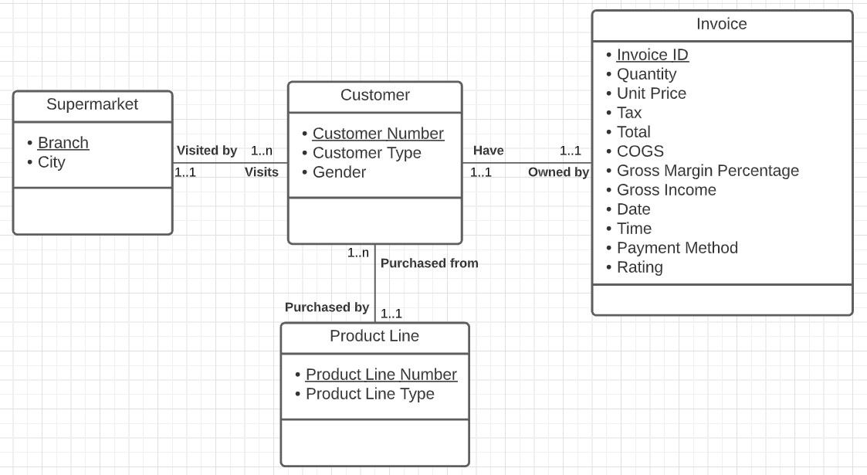

Changes I made to the new E/R diagram:

* Underlined primary keys and added Customer Number and Product Line Number as unique identifiers.
* Moved Unit Price from Product Line entity to Invoice entity because product line doesn’t determine Unit Price.
* Added Tax, COGS, Gross Margin Percentage, and Gross Income to the Invoice entity (Before, I wasn’t sure where to put them).
* Renamed some attributes to better reflect the data.

**E/R Diagram to Relational Translation**

Invoice ID -> Customer Number, Unit price, Quantity, Tax, Total, Payment method, COGS, Gross Margin Percentage, Gross Income, Date, Time, Rating

3NF and BCNF (Yes)

Customer Number -> Customer Type, Gender

3NF and BCNF (Yes)

Branch -> City

3NF and BCNF (Yes)

Product Line Number -> Product Line Type

3NF and BCNF (Yes)

**Relational database schema**

**PK** = Primary Key **FK** = Foreign Key

I limited all field size to an appropriate amount instead of the default 255.

**Branch Table** (Branch (**PK**), City)

**Customer Table** (Customer Number (**PK**), Customer Type, Gender, Branch (**FK**), Product Line Number (**FK**))

**Invoice Table** (Invoice ID (**PK**), Customer Number (**FK**), Unit price, Quantity, Tax, Total, Payment method, COGS, Gross Margin Percentage, Gross Income, Date, Time, Rating)

* Customer Number: Indexed and no duplicates allowed because it’s a one-to-one relationship with the Customer Table.
* Tax, Total, COGS, Gross Margin Percentage, and Gross Income: Changed the data type of these fields to calculated. By doing this, I only need to input Unit price and Quantity, and the rest will be calculated automatically.

**Product Line Table** (Product Line Number (**PK**), Product Line Type)

**GUI designs including Forms and Reports**

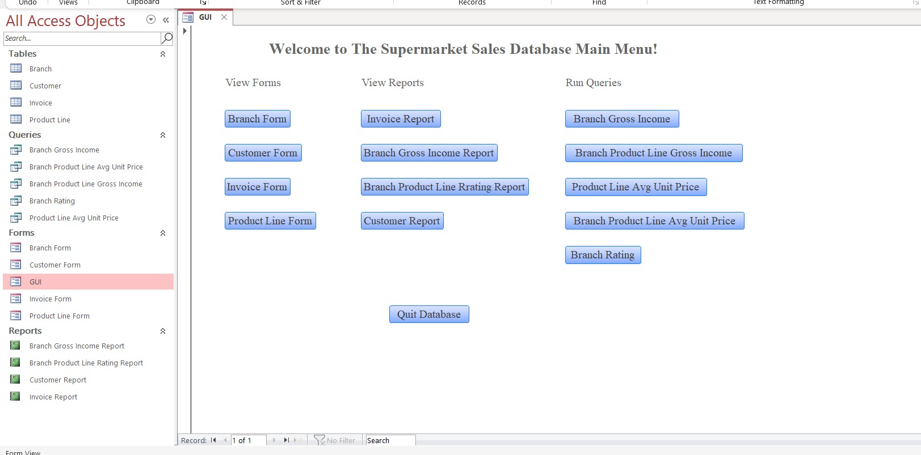Below is my GUI for my database.

Here, you can view forms and reports. You can also choose to run the queries here.

In forms, you can find controls that allow you to add, delete, save, undo, refresh, print record, print form, and exit form. You could also use the magnifier icon to search for a specific record.

Branch Form:

In this form, you can add, delete, or modify branches. Click on “Print Record” if you want to print a specific record. Use the print icon on the top right corner to print the whole form. When you are done, click “Close Form” to go back to the main menu.

Customer Form:

In the form, you can do everything in the Branch Form except there is a new control. “Open Associated Invoice Form” will open the Invoice Form related to the Customer based on the Customer Number.

Invoice Form:

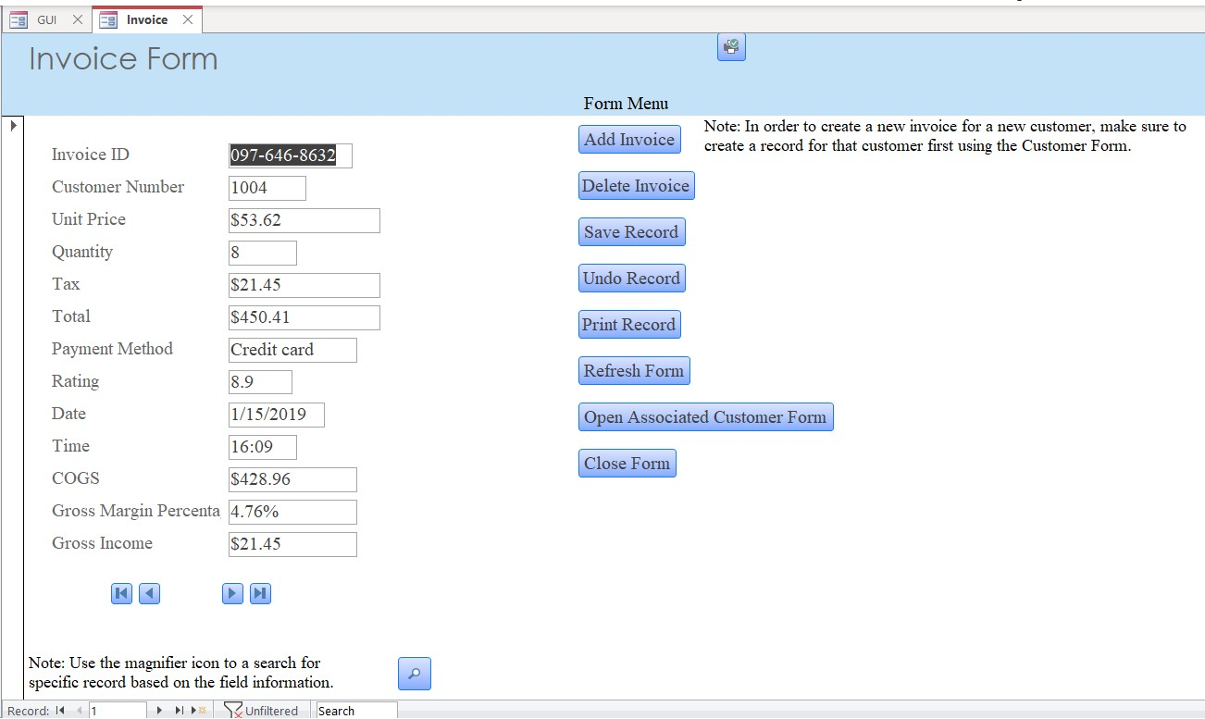The control buttons from this form are the same as the Customer Form, and you can choose to open associated the Customer Form from here.

Product Line Form:

Controls are the same as the Branch Form.

In reports, I added controls that will filter, print report, export report, and exit. You can also use the magnifier icon to search for a specific record.

Invoice Report:

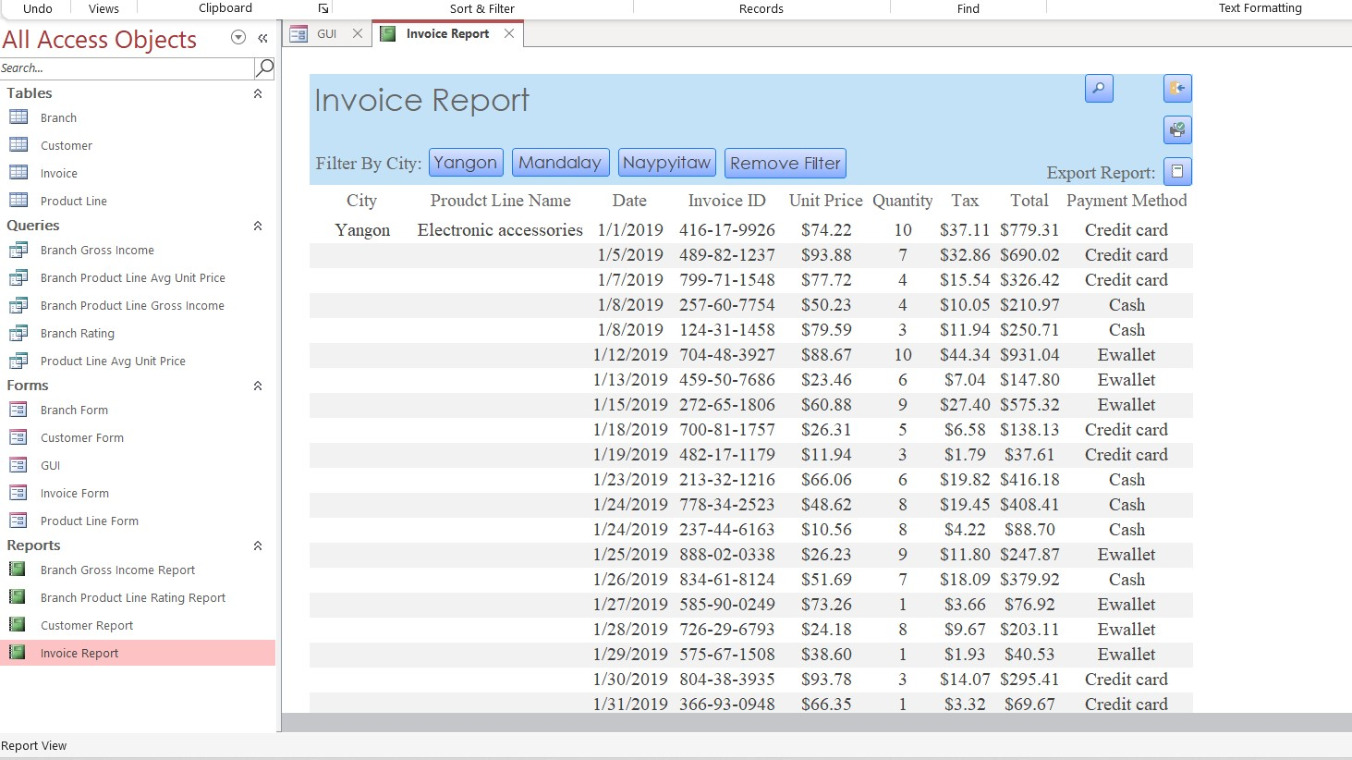This report shows the details of the invoice grouped by cities and product lines. Use the buttons on the top left to filter using city names and click “Remove Filter” to go back to the original state of the form. The magnifier icon can be used to search for a specific record. Also, you have the choice of printing or exporting the form. When you are done, click on the exit icon on the top right corner to go back to the main menu. These controls are similar throughout the reports.

Branch Gross Income Report:

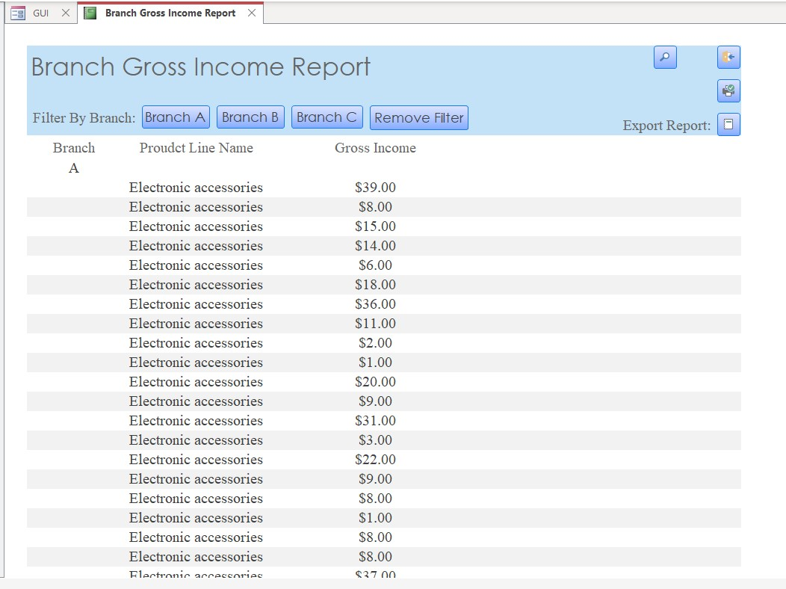This report shows the gross income made from each product line on each transaction. You can filter by branch.

Branch Product Line Rating Report:

This report shows the rating of male/female customers given to each product line, and it’s grouped by branch and product line name. You can filter by branch.

Customer Report:

This report gives the details of every customer. You can filter by membership status (normal or member).

In the main menu, you can also choose to run queries. Below are all the results of queries when you run them.

This concludes my project report and thank you for taking the time to read through this. For more information on the GUI, please take a look at the Microsoft Access database I submitted.